Airline Survival Comparisons: Over 100 years Summary

In what ways has air industry safety changed from 1915-2015? In what ways does air industry safety appear the same?

Looking at the charts below, it is easy to see that one of the ways the air industry has changed is the number of crashes between 1915-2015. The 1965-1975 decade was the highest decade overall for number crashes during this century. Also, many of the crashes in the beginning of the century were a result of military planes. Towards the end of the century, more passenger and cargo planes were involved in crashes. Lastly, there has been a consistent influx of the number of commercial flights per day (~100,000) versus the few available in the beginning of the century.

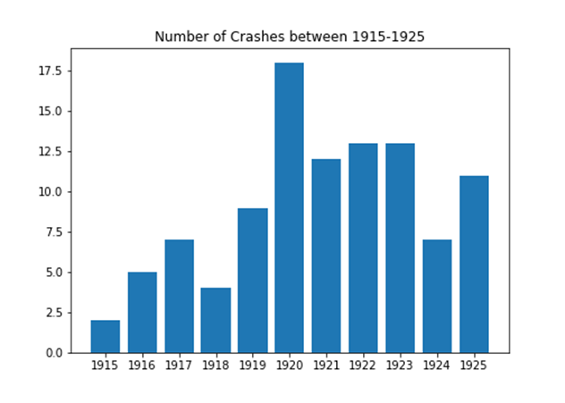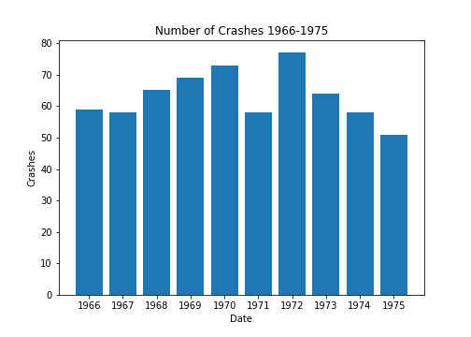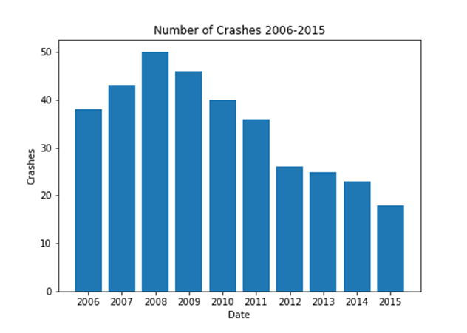

How has the likelihood of survival of a plane crash has changed?

The data supports that if you were involved in a crash in the beginning of the century, the likelihood of survival was extremely low. However, we can assume with the advancement of technology in aviation, the increase in frequency in commercial flights, the decrease in combat using aviation and based on the scatter plots below, the chance of survival increased as the century progressed. Once again, the decade 1966-1975, reflected an increase in all areas of aviation including crashes.

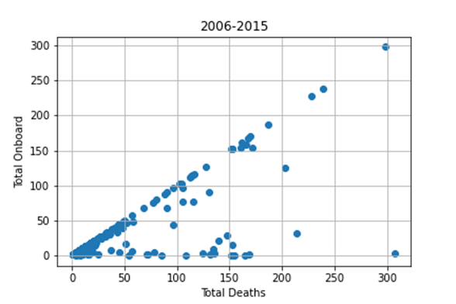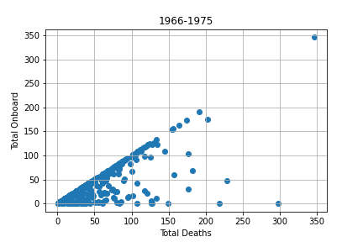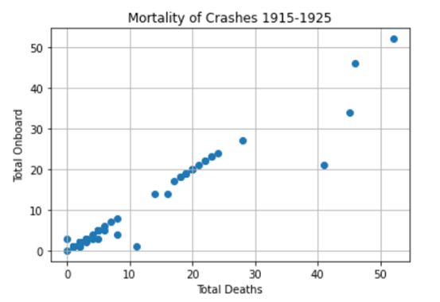

Which plane types are frequently involved in crashes?

In the beginning of the century, the Breguet-14, De Havilland DH-4 and Junker F-13 were the plane models most frequently involved in crashes in the beginning of the century. Both the Breguet-14 & De Havilland DH-4 were bomber planes in WWI. While the Junkers F-13 was a small passenger plane. This suggests the focus on WWI and the beginning of commercial traveling. In the middle of the century and at the end, the Antonov AN, Ilyushin-IL and McDonnell Douglas are the plane models most frequently involved in crashes. Further research reveals that both the Antonov-AN and Ilyushin-IL are foreign plane models mainly used for cargo transport. The McDonnell Douglas is a single aisle passenger carrier. This suggests a new focus of using aviation to ship goods and supports the popularity of commercial flights.

